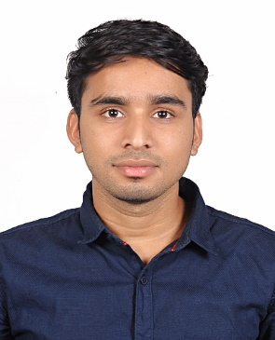

SURENDRA SAMAL
At/Po-NUA THOKAR
Dist-DHENKANAL (ODISHA)
Pin code – 759020
Mob. No.:+97008582889 Email:-surendrasamal000@gmail.com

OBJECTIVE:-

A good Team player with a passion to get into the IT industry as a developer and willing to wok towards the organization’s goals as well as improving my technical skills.

Academic Qualification:-

- BTECH EEE in year 2022 from TEMPLECITY INSTITUTE OF TECHNOLOGY AND ENGINEERING, BHUBANESWAR with 75%.
- Diploma EE in year 2016 from BAJIROUT INSTITUTE OF ENGINEERING AND TECHNOLOGY, Dhenkanal with 71%.
- Passed High school in year 2013 from SIDHA PITHA HIGH SCHOOL THOKAR with 52%.

Technical Skills:-

- Core Java(oops, multithreading, String, Array, Collection Frame work, JDBC )
- PHP
- SQL, Oracle Database,
- Html, CSS, JavaScript

M/s CENTUM RAKON INDIA PRIVATE LIMITED
Responsibilities :- Technician
2017 –2019
- 2.1years experience in Centum Rakon India pvt.ltd on dept.. of Assembly and Quality of OCXO. with team leadership. Fully trained on 5s,kaizen with fulltime working on workshop.
- Maintained speed of assembly and followed all safety procedures.
- Identified any assembly line maintenance issues
- Operated and monitored assembly machines and maintained productivity.
- Completed production targets with deadlines.
- Performing routine inspection and quality test
- Identifying and resolving workflow and production issues.
- Acceptance sampling & control charts.
- Process protocol & process control ,lean six sigma collaboration, quality control inspection ,5s methodology
- Monitored operation output and associate production standards.
- Accepted or reject product samples after full quality inspection.

Project:-

- Automatic pneumatic grinding machine operated by PLC
- Voice LED Notice Board

Training

23/09/2016 - 22/032017

- 6 month training on ADMMA including- machine operation, maintenance, HMI, CNC, PLC, SCADA, simatic manager, pneumatics, hydraulics etc from recognize training center of CTTC, Bhubaneswar

Multimedia Knowledge

- Using Adobe premiere pro, After Effect, Photo shop, illustrator. I have edited over 70 videos, including wedding, chroma remove ,vfx animations and motion graphics, Youtube videos, Instagram reels.

Achievements:-

- In my previous company, I earned certificate for improving the tools. These tools allow more production and save time and can be used anyone.

Extra-Curricular Activities:-

- Video Editing.
- Photography, Cinematography

Personal Details: -
Date of birth : May-07-1998.
Father’s name : Chandramani Samal
Strengths : Hard working & having strong will power.
Marital Status : Unmarried.

DECLARATION:-
I hereby declare that above written particulars are true to the best of my knowledge and belief. I am ready to furnish any details or certificates needed for verification, if required.

Date:- Surendra Samal
Place:-

